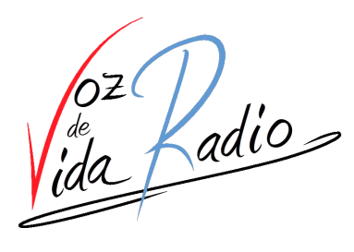

http://vozdevida.org

For the attention of the Google Play Review Team:
As owners of the "VOZ DE VIDA RADIO" brand, and according to the policy for "Impersonation and Intellectual Property" at developer policy center, we authorize the use of our brand name, logos, trademark, copyright, trade secret and other distinctions or proprietary rights to LCINTERNET.ES for the development and publication of our APP on Google Play.
Therefore, we request that any content that is published in the APP of our brand by LCINTERNET.ES developer team, now and in the future, will be authorized by us until new order.
Best regards

Paco Lobato Alvarez
President

